OPD to QL Miracle Systems Centronics I/Face

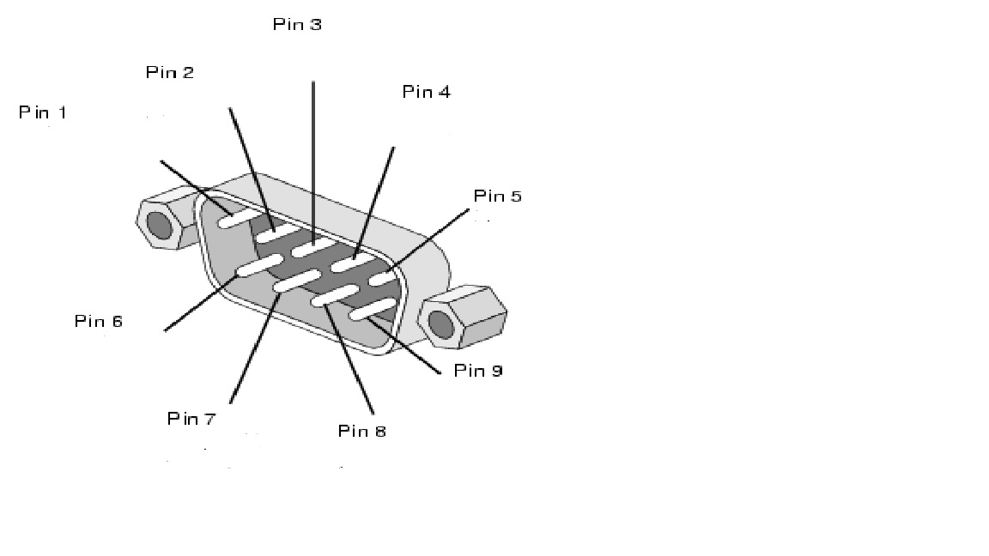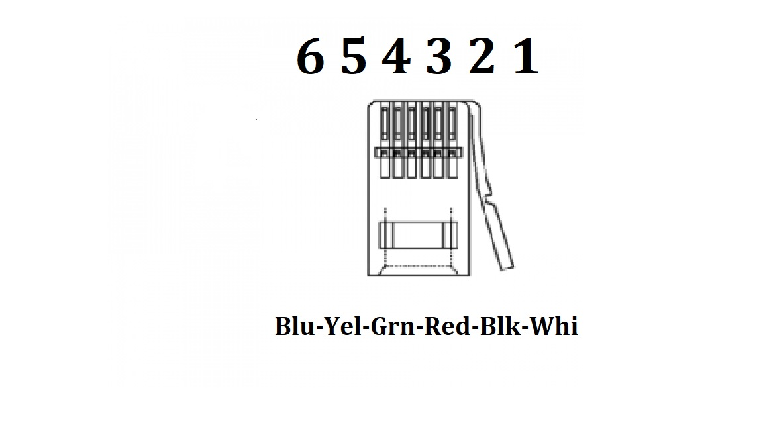
OPD Pin 1 to Telephone Pin 5 Yellow
OPD Pin 2 to Telephone Pin 6 Blue
OPD Pin 3 to Telephone Pin 3 Red

